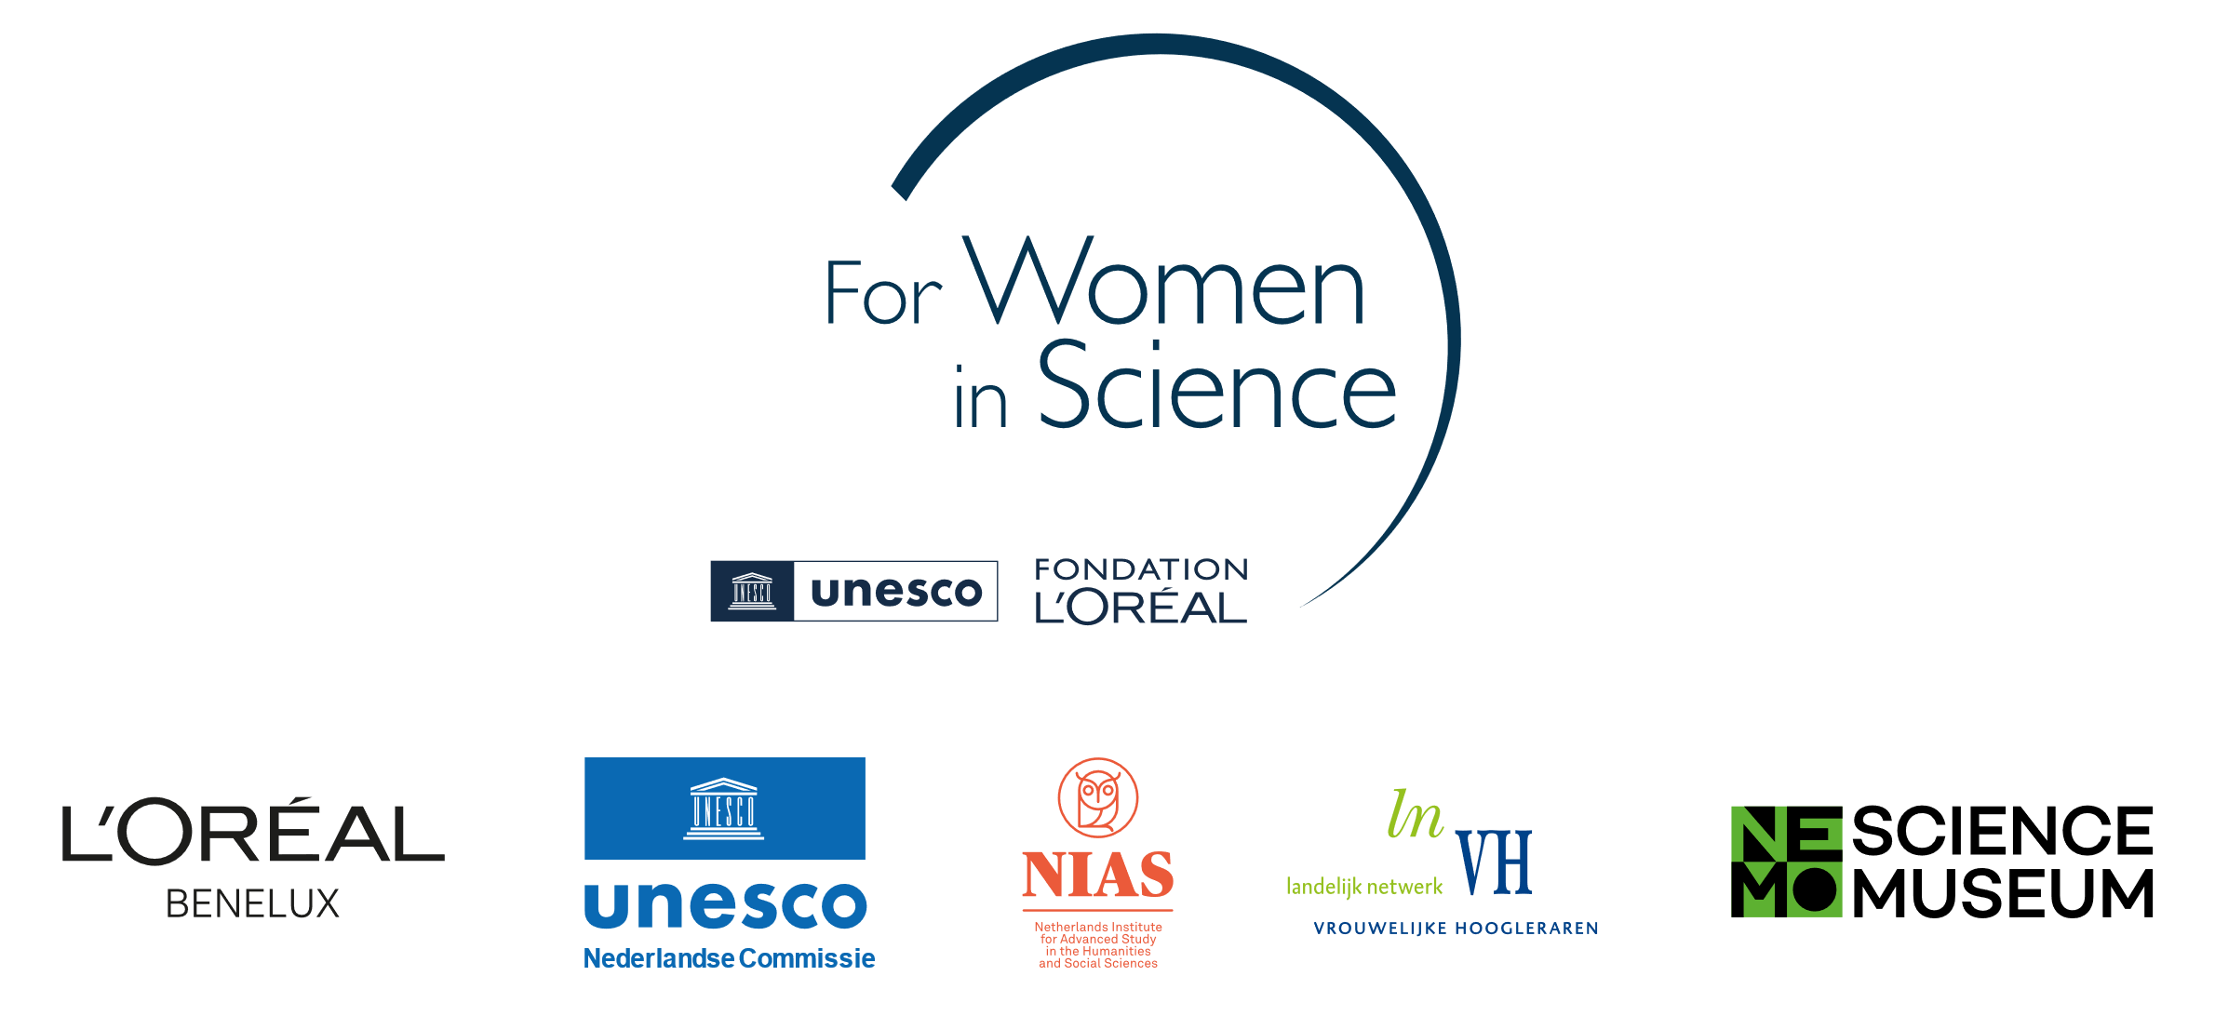

­­­­

Application form

Dutch L’Oréal-Unesco Fellowship For Women in Science 2025/2026

*Please read the Call for Proposals and the FWiS regulations before completing this form.*

**Details of the applicant**

|  |  |
| --- | --- |
| Title(s) |  |
| First name |  |
| Surname |  |
| Place and date of birth |  |
| Nationality |  |
| Postal address |  |
| Telephone |  |
| Mobile phone |  |
| Private e-mail  Work e-mail |  |
| Personal website/social media accounts (if relevant) |  |

**Research position and experience**

|  |  |
| --- | --- |
| University/Research institute |  |
| Faculty/Department |  |
| Current position |  |
| Discipline(s)/specialization |  |
| Type of employment contract (please tick)[1] | Temporary  Tenure |
| Master degree(s): discipline, university/research institute and year |  |
| PhD degree(s): discipline, university/research institute and year |  |
| Number of years work experience post PhD |  |
| Total duration of maternal/parental/family care leaves taken (if applicable)[2] |  |

**Fellowship project proposal**

Title of the proposed project:

Summary of the project in plain language (max. 150 words):

**In a separate document, using the ‘project proposal’ form,** provide a full description of the proposed project, presenting the following elements. Elements 1 through 5 should take up a maximum of 1500 words (excl. references):

1. Title of the proposed project
2. Research topic and research questions
3. Academic and societal relevance of the project
4. Description of the benefit of carrying out the project at [NIAS-KNAW](https://nias.knaw.nl/) for both the proposed project, *as well as* the benefit for NIAS-KNAW’s interdisciplinary research community (max. 300 words)
5. Prospection of the potential impact of the Fellowship on the applicant’s academic career (max. 150 words)
6. Proposed work plan, including activities, time schedule and a budget summary
7. Summary of the project in plain language (max. 150 words)

**Fellowship application – practical details**

Application for the academic year 2025/2026 (please tick):

No preference

First semester (1 September 2025 – 23 January 2026)

Second semester (2 February 2026 – 26 June 2026)

Please indicate if you will apply for housing or reimbursement of travel costs:[3]

I will commute and apply for standard reimbursement of travel costs (max € 250 p/month)

I will apply for a studio apartment (1 or 2 persons)

I will apply for a family apartment (2 bedrooms)

**Application portfolio**

Please make sure your application portfolio consists of the following:

1. This application form
2. A full project description, using the project proposal form
3. Your CV, highlighting three achievements relevant to the proposed project at NIAS-KNAW (3 pages max.)
4. Two letters of recommendation by (international) specialists in your field

These letters should make explicit reference to the academic and societal relevance of the proposed project and to the applicant’s potential to maintain a high level of quality in her future career. Note that the jury will not accept letters from relatives or others that have a personal, non-work related relationship with the candidate that could lead to conflict of interest.

Please submit your application portfolio (5 documents in total) by e-mail no later than 28 February 2025 to Dr. Jon Verriet, Netherlands Commission for Unesco: [jverriet@unesco.nl](mailto:jverriet@unesco.nl).

1. Your employment contract must cover the duration of the fellowship.
2. Periods of maternity leave, part-time work, and family care allow for an extension of the upper limit of 10 post-PhD years by up to 18 months per child (or case).
3. Note that you are only eligible for accommodation if travel time exceeds 1.5 hours (single journey from home town train station to Amsterdam CS). More information on the types of subsidized NIAS-KNAW housing can be found [here](https://nias.knaw.nl/what-we-offer/practical-matters/accommodation/).